# TUPLE :-

* A tuple is a collection data type in Python that is similar to a list but is immutable, meaning that once it is created, its elements cannot be changed or modified. Tuples are defined using parentheses ‘**()**’.



* Key characteristics of tuples:
* **Immutable :** Once a tuple is created, you cannot add, remove, or modify elements.
* **Ordered :** Elements in a tuple maintain their order
* Can contain different data types.
* **Accessing Elements** : Elements in a tuple are accessed using indexing, similar to lists. Indexing starts from 0 for the first element.



* **Slicing :**
* **Length of a Tuple:**



* **Tuple Concatenation:**



* **Tuple Repetition:**



* **Tuple Unpacking:**



* **Methods:** Tuples have limited methods compared to lists due to their immutability.

*count(x):* Returns the number of occurrences of element x in the tuple.

*index(x):* Returns the index of the first occurrence of element x.

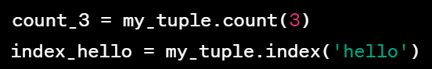

* **Nested Tuples:**



* **Named Tuples:**

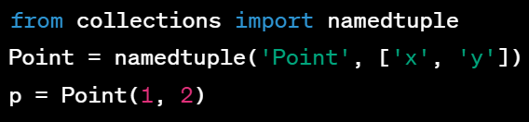

* Use tuples when you have a collection of items that should remain constant throughout the program.
* Tuples are often used for returning multiple values from a function.

# SET :-

* A set is an unordered collection of unique elements in Python. Sets are defined using curly braces ‘**{}**’.



* Key characteristics of sets:
* **Unordered :** Elements have no specific order.
* **Unique elements :** Sets cannot contain duplicate elements. It removes them automatically.
* **Mutable :** You can add/ remove elements in sets.
* **Accessing Elements:** Can’t access using indexing.

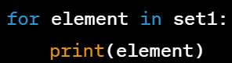

* **Set Operations:**
* **UNION :** Returns a set containing all unique elements from both sets.



* **INTERSECTION :** Returns a set containing common elements between two sets.



* **DIFFERENCE :** Returns a set containing elements that are in the first set but not in the second.



* **Modifying Sets:**

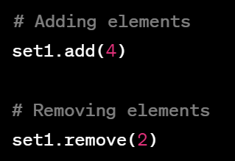

* **Set Comprehensions:** Like lists and dictionaries, sets support comprehensions for concise creation**.**



* **Frozen Sets:** Immutable version of sets is called ‘frozenset’**.**



* **Subset and Superset:**

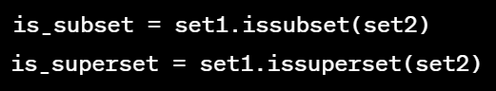

**# PRACTICE QUESTIONS :-**

* **TUPLE**

1. Create a tuple with elements 5, 'apple', and 2.5.
2. Access the third element of the tuple created in question 1.
3. Concatenate two tuples: (1, 2, 3) and (4, 5, 6).
4. Create a tuple with five elements, and then unpack it into five variables.
5. Check if the element 'banana' exists in the tuple (1, 'apple', 3.14, 'banana')

* **SET**

1. Create two sets: {1, 2, 3, 4} and {3, 4, 5, 6}.
2. Find the union of the sets created in question 1.
3. Find the intersection of the sets created in question 1.
4. Add the element 'orange' to the set {'apple', 'banana'}.
5. Remove the element 3 from the set {1, 2, 3, 4, 5}.

* **MIXED**

1. Create a tuple with elements 'apple', 3, and a set with elements 1, 2, 3.
2. Convert the tuple (7, 8, 9) to a set.
3. Create a set with the common elements between the tuple (1, 2, 3) and the set {3, 4, 5}.